Prerequisites -1

|  |  |
| --- | --- |
| Team ID | PNT2022TMID43975 |
| Prerequisite | IBM Cloud service |

Signup Page:

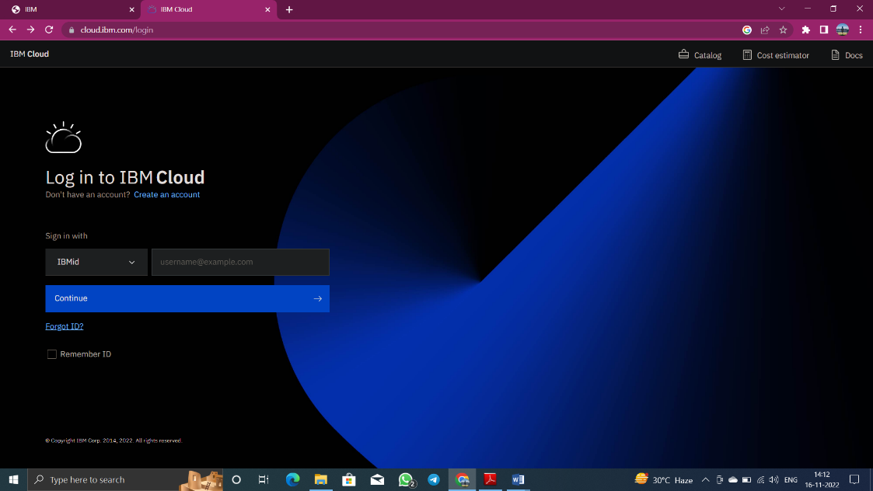

My Profile:

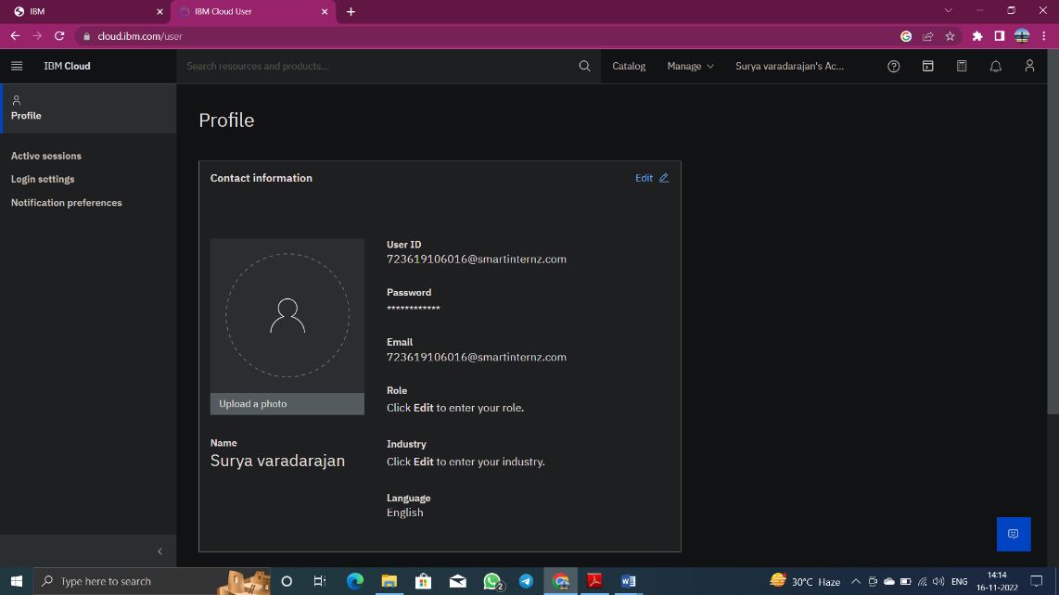

Home Page:

